
a
Company
Logotype

Cone Beam Computed Tomography- Report



Porur Dental X-rays & CBCT

Patient Name : Miss. Sowndarya | Date of Report : 31.03.2024
Age/ Gender : 27 years/ Female | Region of Interest : CBCT Maxilla
Referring doctor: 32 Dental | Indication : Implant assessment
Clinical Notes: Nil
PATIENT INFORMATION

CBCT- Maxilla provided
CBCT – IMAGE DETAILS

RADIOGRAPHIC INTERPRETATION

- Completely missing crown and root portion in relation to: 11, 12, 13.
- The maxillary alveolar ridge is present with normal trabecular pattern.
 | 11 region | 12 region | 13 region
Sub-Crestal (in mm) | 7.29 | 4.72 | 7.67
Mid- Crestal (in mm) | 7.77 | 4.57 | 8.46
Distance between the alveolar ridge and floor of the nasal cavity (in mm) | 12.91 | 20.18 | 12.6
IMPLANT ASSESSMENT

RADIOGRAPHIC IMPRESSION

- Partially edentulous maxillary arch.

Kindly correlate with clinical findings


IMAGES FOR REFERENCE

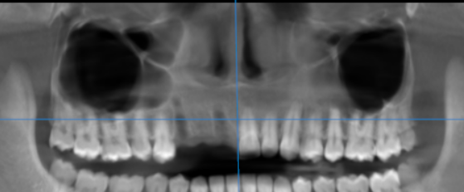

3-DIMENSIONAL VIEW
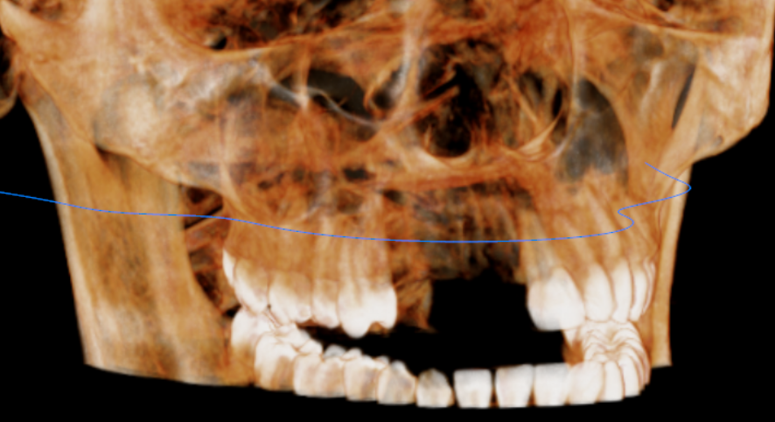

CROSS SECTIONAL VIEW

11 region | 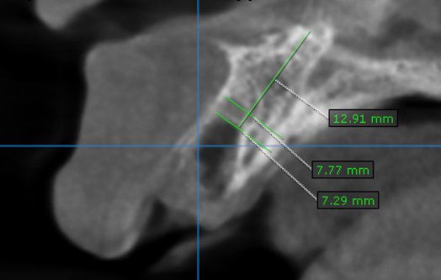
12 region | 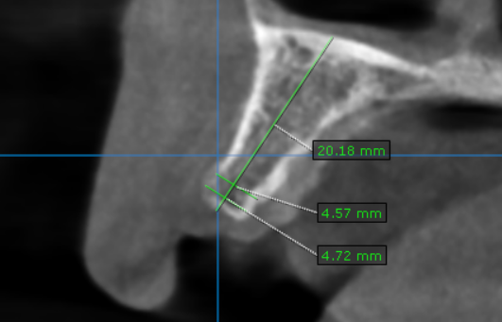
13 region | 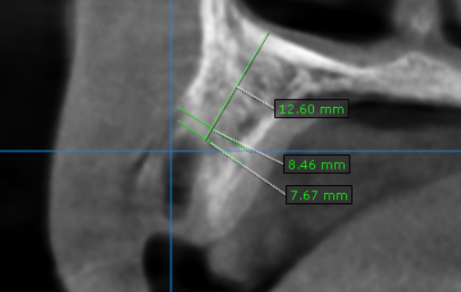

**** End of report ****

